* **Delete a User that doesn’t exist**

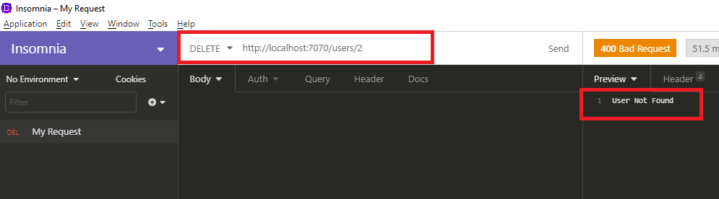

* **Delete an interview that doesn’t exist**

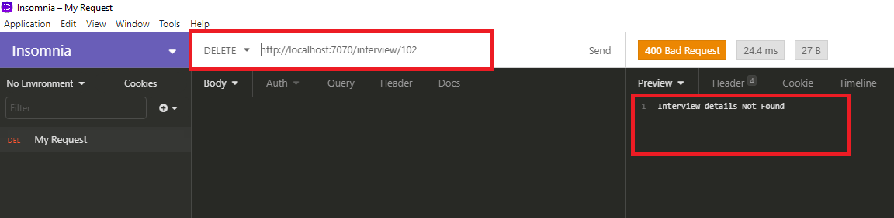

* **User id must be not null and unique**

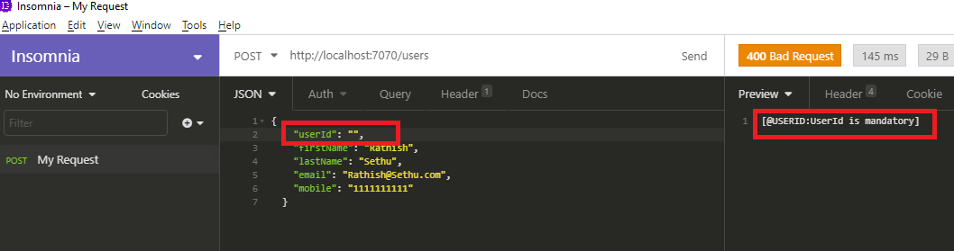

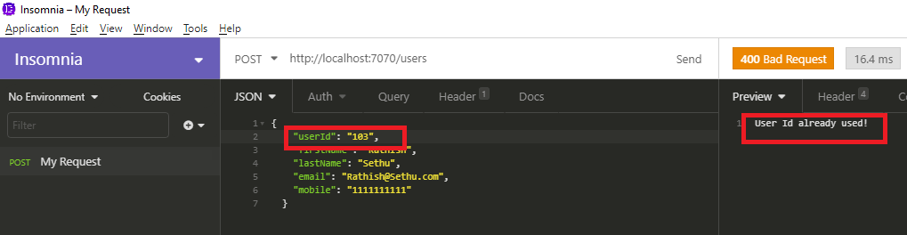

* **Interview Id must be not null and unique**

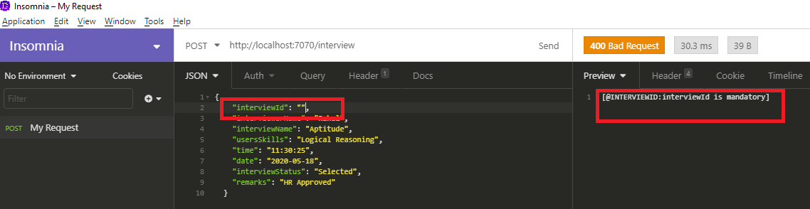

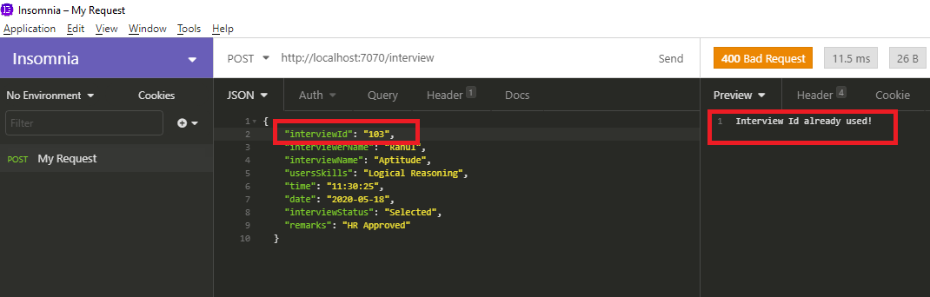

* **FirstName is not null, min 5 and max 30 characters.**

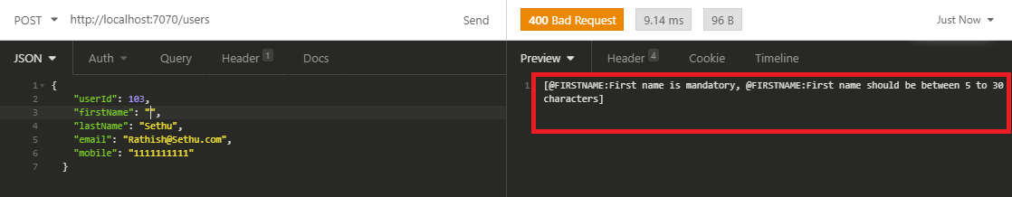

* **Last Name is not null, min 3 and max 25 characters.**

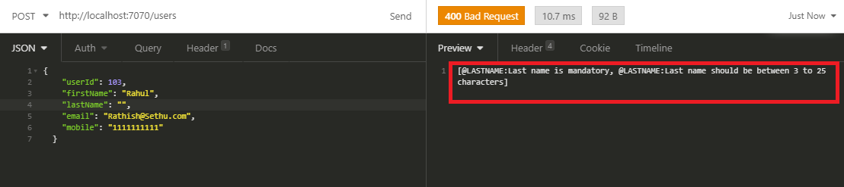

* **Email is not null, and it should be valid mail id.**

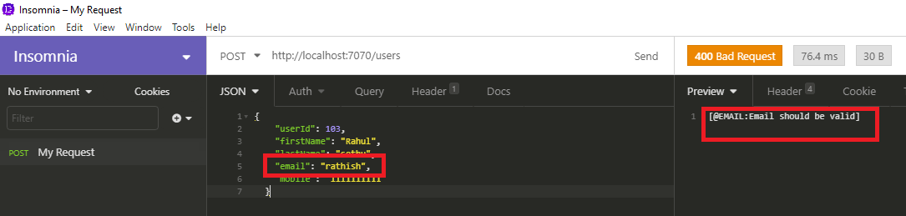

* **Mobile is not null, min 10 and max 10 character.**

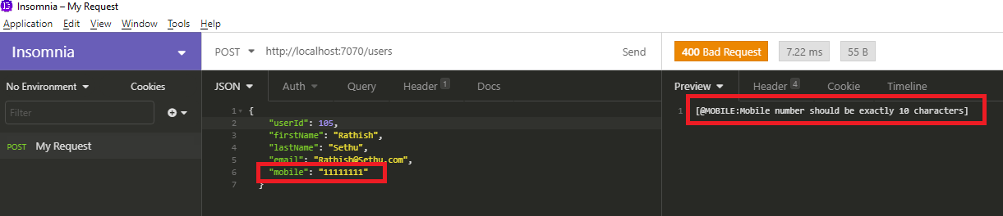

* **Interviewer Name is not null, min 5 and max 30 characters.**

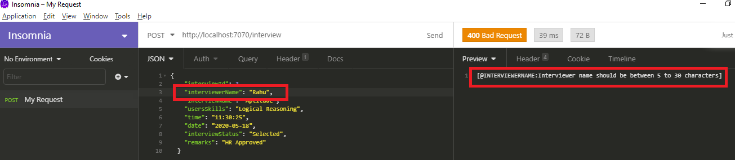

* **Interview Name is not null, min 3 and max 30 characters**

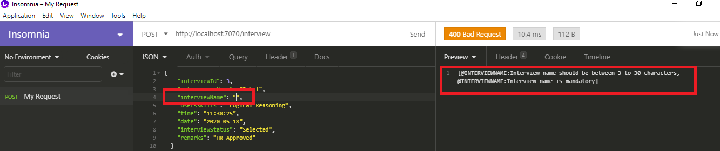

* **User Skill is not null, min 5 and max 30 character.**

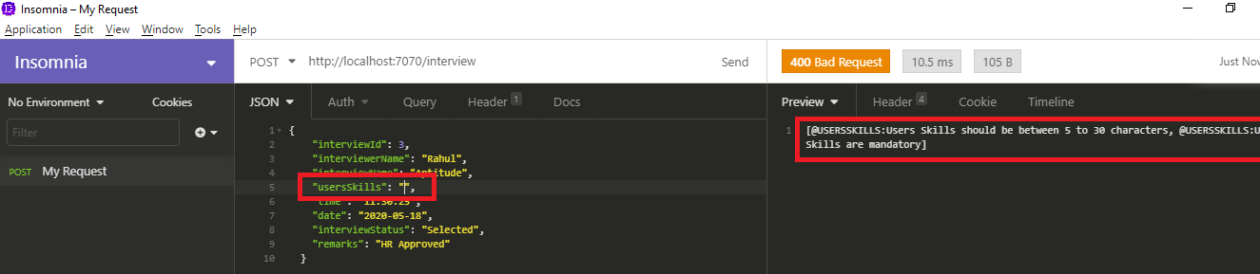

* **Interview Status is not null, min 5 and max 100 character.**

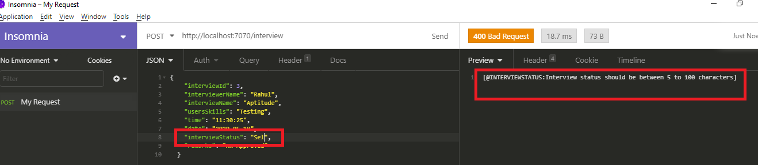

* **Remarks is not null, min 5 and max 100 character.**

